

## Walchand College Of Engineering, Sangli.

#### (An Autonomous Institute)

**Department of**

#### Computer Science and Engineering

TY CSE Mini Project-I

Report

On

Product Tracker Application for Multiple Ecommerce Websites

Submitted by

**Shreyash Malu 2019BTECS00057**

**Aditya Sarnobat 2019BTECS00042**

**Onkar Gavali 2019BTECS00037**

Under the Guidance of

**N.L Mudegol**

Guide

Computer Scienece & Engg. Dept, WCE, Sangli.

**2021-2022**



Walchand College of Engineering, Sangli

(An Autonomous Institute)

**Department Of**

**Computer Science and Engineering**

### CERTIFICATE

This is to certify that the Project Report entitled, **”****Product Tracker Application from multiple E-commerce websites”** submitted by Mr./Ms. Shreyash Malu, Aditya Sarnobat, Onkar Gavali, to Walchand College of Engineering Sangli, India, is a record of bonafide Project work of course Mini Project – 1*”* carried out by him/her under my/our supervision and guidance and is worthy of consideration for the award of the degree of Bachelor of Technology in Computer Science & Engineering of the Institute.

|  |  |  |
| --- | --- | --- |
| **N.L Mudegol** |  | **Dr. M. A. Shah** |
| Guide |  | Head Of Department |
| Computer Sci. & Engg. Dept, |  | Computer Sci. & Engg.Dept, |
| WCE, Sangli. |  | WCE, Sangli |

# Acknowledgement

We would like to express our special thanks of gratitude to our guide Ms. N.L Mudegol Mam as well as our HOD Dr. M. A. Shah who gave us the golden opportunity to do this wonderful project on the topic **Product Tracker Application from multiple E-commerce websites**, which also helped us in doing a lot of research and we came to know about so many new things. We are really thankful to them. Secondly, we would also like to thank the teammates who worked together in finishing this project within limited time. Finally, thanks to all who supported the project.

# Declaration

I hereby declare that work presented in this project report titled **”** **Product Tracker Application from multiple E-commerce websites”** submitted by me in the partial fulfillment of the requirement of the award of the degree of **Bachelor of Technology (B.Tech)** Submitted in the **Department of Computer Science & Engineering, Walchand College of Engineering, Sangli**, is an authentic record of my project work carried out under the guidance of Ms. N.L Mudegol Mam

Date :

27-11- 2021

Place : Sangli

(Shreyash Malu) 2019BTECS00057

(Aditya Sarnobat) 2019BTECS00042

(Onkar Gavali) 2019BTECS0037

## Table Of Contents

1. Project title 6
2. Abstract 7
3. Introduction and Related work 8
4. Problem statement 8
5. Objectives 9
6. Methodology 10
7. Diagrams 11
8. Testing (Unit, System, Integration etc.) 12
9. Results and Conclusion 13
10. References 14
11. Annexure A 15
12. Minutes of meeting with mentor
13. Acceptance Email
14. **Project Title –** Product Tracker Application from multiple E-commerce websites

#### Abstract

1. The Prices of E-Commerce Products are pretty Much Volatile

and Sometimes we Regret to Buy a Product at Higher Price.

1. Also, there are many ecommerce websites which provides same product but the price may be different on the websites
2. There should be a price tracking system to keep track of prices on ecommerce websites
3. This tracking can be done with the help of web scrapping
4. Also, we can compare the price of product on different websites with the help of web scrapping

#### Introduction and Related work

1. There are some websites which allow users to see and compare products from different websites but they don’t provide price tracking feature
2. Here we are providing feature where user can track and get notified from multiple ecommerce websites such as Flipkart and Amazon and can purchase his/her favorite product at the lowest price

#### Problem statement

* 1. To Create a Website Which will help the Customer by

notifying Changes in Prices Of Product

* 1. Sending user a email when product price drops
  2. Providing a interface through which user can analyse product prices through graphs and can also add a product for tracking

#### Objectives

#### To Create A Web Page Where User Can Register a Product To Track.

#### Using Web Scraping Technology For Tracking Of a Particular Product

#### Allowing users to analyze price of the product with help of graphs and charts from the website

#### Users will receive an email every time price gets low

#### To save Customers valuable Time and Money

#### Methodology

* 1. Here we will use agile methodology for the development purpose
  2. User can input URL or search the product
  3. Using Web scraping and API calls we will get data about products
  4. Search history is stored in database for future suggestions
  5. We will also scrape other information from website such as special deals etc

**Price Checking Algorithm**

* 1. Price history for last 7 days is stored in the database
  2. According to it graphs will be generated which will allow customers to check lowest price for the product in last 7 days
  3. At any time if price gets low than the current price customers will receive an email containing link, price and name of the product
  4. Customer has to only provide product URL for once and he is all set to track his favorite product

**Working of Scrapper**

1. We have deployed our scrapper on Heroku platform
2. It will check and update price of every product in database in every 25 mins
3. It is completely automated as it is fetching data directly from firebase
4. Selenium will safely access the ecommerce websites from chrome browser drivers and scrap the details about the product
5. Ecommerce websites cannot block the requests from selenium as those were generated from chrome drivers

#### Project diagrams

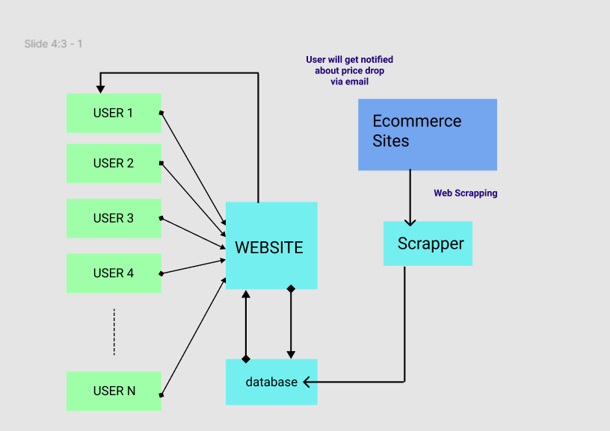

#### Testing (Unit, Integration and System)

* 1. API Testing

Price Check API returning proper results

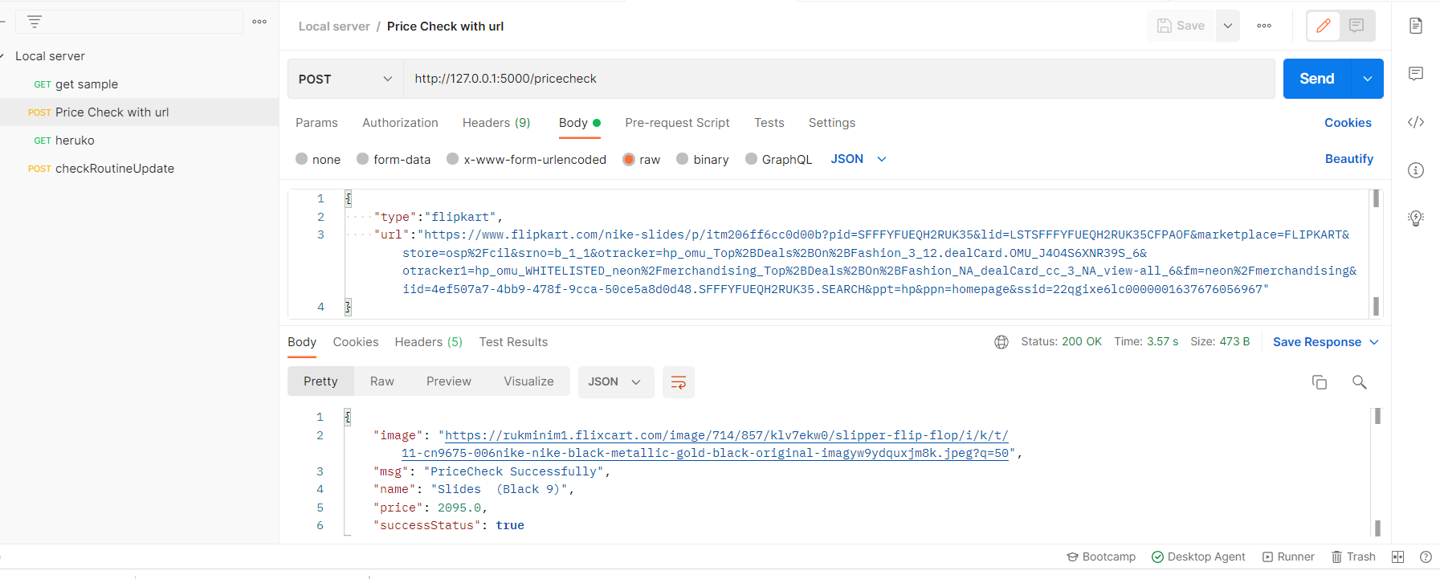

* 1. Selenium Scrapper Testing (deployed on Heroku)

Scrapper returning status of price change after checking for every 25 mins

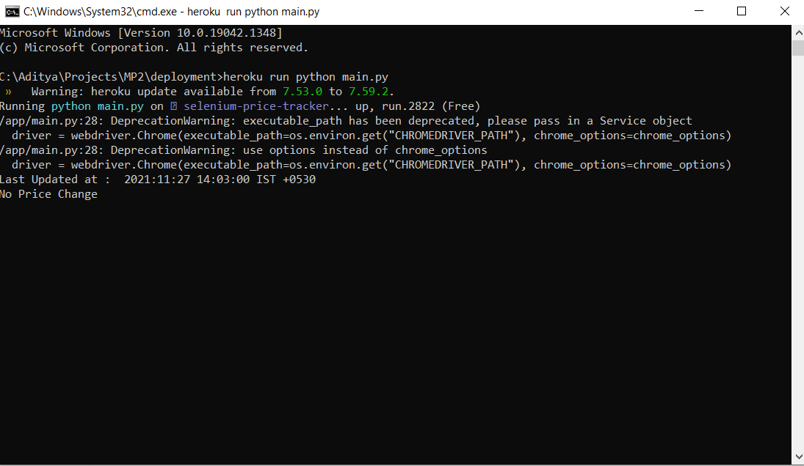

.

#### Results and Conclusion

#### Our website will allow customers to track & compare product prices from different ecommerce websites to grab best deals on products which helps them to save money and time

#### References

* 1. <https://webservices.amazon.com/paapi5/documentation>
  2. <https://seller.flipkart.com/api-docs/order-api-docs/>
  3. <https://www.crummy.com/software/BeautifulSoup/bs4/doc/>

**Annexure A**

1. **Minutes of meeting with mentor (For MP-II Only)**

|  |  |  |  |
| --- | --- | --- | --- |
| **Sr. No** | **Day, Date and time of meeting** | **Discussion regarding (SRS, implementation, testing, problems during implementation, progress review etc.)** | **Meeting Summary** |
| **1** | 7-11-2021 | Project Introduction and Suggestions and Improvements | We conducted meeting with our mentor and explained him about our project idea and asked for suggestions and improvements. Sir suggested to show the analysis of the prices in form of graphs we have implemented what sir suggested during the meeting |
| **2** | 8-11-2021 -> 20-11-2021 | Project suggestions, doubt resolving time to time on our WhatsApp group | Sir suggested us to create a WhatsApp group and we were updating him about our projects on the WhatsApp group. Also got suggestions and resolved our technical doubts |
| **3** | 28-11-2021 | Final Project presentation , Q&A session with mentor | We have presented our completed project to our mentor Rohit Chougule sir and had discussion about our project . Sir guided us about how can we scale this project for millions of users , handling user traffic using system design concepts . We aim to learn and use these concepts in our project to make it scalable for millions of users after ESE exam |

1. **Acceptance Letter from Mentor for MP2**

